Europe After Convergence: Governing Permanent Transition
Les Rencontres Economiques d’Aix-en-Provence
Tatiana Molcean, United Nations Under-Secretary-General and Executive Secretary of UNECE

Introduction
There are moments when societies feel that they are passing from one order to another. There are also moments when the idea of a stable order itself begins to feel elusive. Europe is living through such a moment. The familiar reference points of the post-Cold War period have weakened. Geopolitical assumptions have been overturned. Economic models now face slower growth, higher borrowing costs and slower productivity. A less visible and often overlooked challenge is the demographic shift, which is reshaping labour markets, families, care systems and public finances. Climate risks are amplifying while trust in institutions has become more fragile, even in countries with deep democratic traditions.
A further transition may soon come into view: the transition from war to peace in Ukraine. It is not possible, and would not be responsible, to assume the timing, terms or durability of such a peace. But Europe should already be preparing intellectually and institutionally for the scale of the task that would follow. Europe should prepare for peace. A just and durable peace would not end transition. It would open one of the most complex transitions the region has faced since 1945: recovery, reconstruction, return, reintegration, environmental repair, infrastructure rebuilding, institutional renewal and the anchoring of Ukraine’s future in a stable European order.
For many citizens the future no longer feels like a destination. It feels like a succession of adjustments: one more reform, shock, or emergency. The political consequences are visible. People who feel that change is done to them rather than with them become less willing to support the next change that is required. They withdraw confidence from institutions, look for protection in narrower identities, and become vulnerable to narratives that promise certainty where none can honestly be offered.
For those of us from Central and Eastern Europe, this sensation is familiar. The last thirty-five years have been marked by transition: from planned to market economies; from authoritarian systems to democratic institutions; from isolation to European integration; from national reconstruction to regional interdependence. In the Republic of Moldova, where I served in government before joining the United Nations, transition was never an abstract concept. It meant rewriting laws, rebuilding institutions, negotiating trade arrangements and modernizing public administration. It meant explaining to citizens why difficult reforms were necessary, and then living between the promise of reform and the patience required to realize it.
One lesson from that experience is now relevant for many more countries. We imagined transition as a temporary phase: a bridge between a difficult past and a more settled future. The assumed destination was prosperity, democratic consolidation and integration into regional and global systems. Today, that assumption has weakened. The challenge before Europe is to govern in an age where transition itself has become permanent.

The post-Cold War promise and its limits
The decades after 1989 were shaped by a powerful belief in direction. The end of the Cold War opened a path towards liberal democracy, market economies, European integration and rising living standards. This belief was never universal, and its distributional effects were always uneven. Yet it created a political grammar that mattered. Reform could be justified as movement towards a recognizable horizon. Painful adjustment and losses for some people were defended as the price of convergence.
Francis Fukuyama's famous argument about the “end of history” is often caricatured, but its influence was not only intellectual. The broader atmosphere of the period suggested that political and economic systems were moving, however unevenly, towards a stable settlement. For Central and Eastern Europe, the language of transition carried that meaning. Countries were not simply changing; they were catching up, joining, harmonizing and converging. The European Union offered one of the most concrete expressions of that horizon, through accession processes, regulatory alignment, investment, mobility and the promise of shared prosperity.
The achievements have been substantial. Many countries modernized institutions, expanded trade, improved infrastructure and raised incomes. Millions of citizens gained new freedoms and opportunities. The transformation of Europe after 1989 remains one of the most significant political and economic achievements of modern history.
Yet this convergence was uneven and cracks started to appear. Some regions prospered while others experienced depopulation, deindustrialization or persistent insecurity. The benefits of openness were felt differently across generations, territories and sectors. The financial crisis of 2008 damaged confidence in economic management. The annexation of Crimea in 2014 and the full-scale invasion of Ukraine in 2022 shattered assumptions about European security. And the Covid pandemic exposed the fragility of systems that had been optimized for efficiency but not always for resilience.
The result is a Europe in which the older story of convergence no longer provides sufficient persuasion, and the direction of travel is being contested. Citizens are asked to support climate transitions, fiscal consolidation, defence spending, pension reform, migration management, reconstruction, enlargement and institutional adaptation, all at the same time. Each may be necessary – but taken together they feel overwhelming.

The new condition: overlapping transitions
The defining feature of the present is not the existence of transition, as societies have always faced change. What is distinctive now is the simultaneity of transitions that affect one another. Europe is managing at least six at once.
The first is geopolitical. The war against Ukraine has transformed the security environment, the energy landscape and the debate about Europe’s strategic responsibilities. It has also reminded the region that peace is not guaranteed. It depends on institutions, deterrence, diplomacy, economic resilience and sustained public support.
The second is demographic. People in Europe are living longer than ever before, while fertility rates remain below replacement levels in most countries of the region. As a result, the age structure of European societies is changing. The median age continues to rise, and older persons will make up an increasing share of the population in the decades ahead. This is one of the great achievements of social and economic development, reflecting advances in health, education and living standards. At the same time, it represents a profound transformation that will influence labour markets, lifelong learning, housing, care systems, public finances and relationships between generations.
The third is economic. Europe faces a more difficult growth environment than in earlier decades, in the context of geopolitical shifts, competition and protectionism. Eastern Europe and Central Asia also faces weaker growth prospects and productivity constraints, not least because of the continuing Gulf crisis. For emerging and developing economies in the broad European region, this is particularly consequential. Countries that are ageing before reaching high income levels creates a narrow window for productivity growth, skills upgrading and institutional strengthening.
The fourth is ecological. Climate change is already changing budgets, infrastructure planning, agriculture, insurance markets and the politics of energy. The green transition requires investment, regulatory change and behavioural adaptation. Its legitimacy depends on whether it is perceived as fair. If climate policy is experienced mainly through higher costs by households that already feel insecure, it will generate resistance even among people who accept the reality of climate risk.
The fifth is institutional. Trust in public institutions is uneven and politically fragile. The OECD’s 2025 Government at a Glance reports that across surveyed OECD countries, around four in ten people have high or moderately high trust in national government, while a larger share report low or no trust. Eurobarometer data show higher trust in the European Union than in many national governments, but the broader picture remains mixed.
The sixth is the transition to peace in Ukraine, that Europe must be ready to support when conditions allow: The World Bank, the United Nations, the Government of Ukraine and the European Commission. have estimated Ukraine’s recovery and reconstruction needs in the hundreds of billions of dollars over a ten-year horizon. Those figures will evolve with the course of the war, but they already make clear that reconstruction will be much more than a financing exercise. It will require coordination across housing, transport, energy, water, environmental remediation, demining, local governance, social protection, jobs, return and institutional reform.
These transitions interact. Ageing affects growth and public expenditure. Slower growth narrows fiscal space. Narrow fiscal space complicates investment in climate adaptation, defence, infrastructure and care. War reshapes energy, security and public finance. Reconstruction will test the capacity of governments, cities, donors, firms and international organizations to align speed with accountability. Perceived unfairness weakens trust. Lower trust makes reform harder. Delayed reform raises costs. The cycle can become self-reinforcing.
The task of leadership is therefore not to manage a list of separate policy files. It is to understand the system in which these transitions meet.

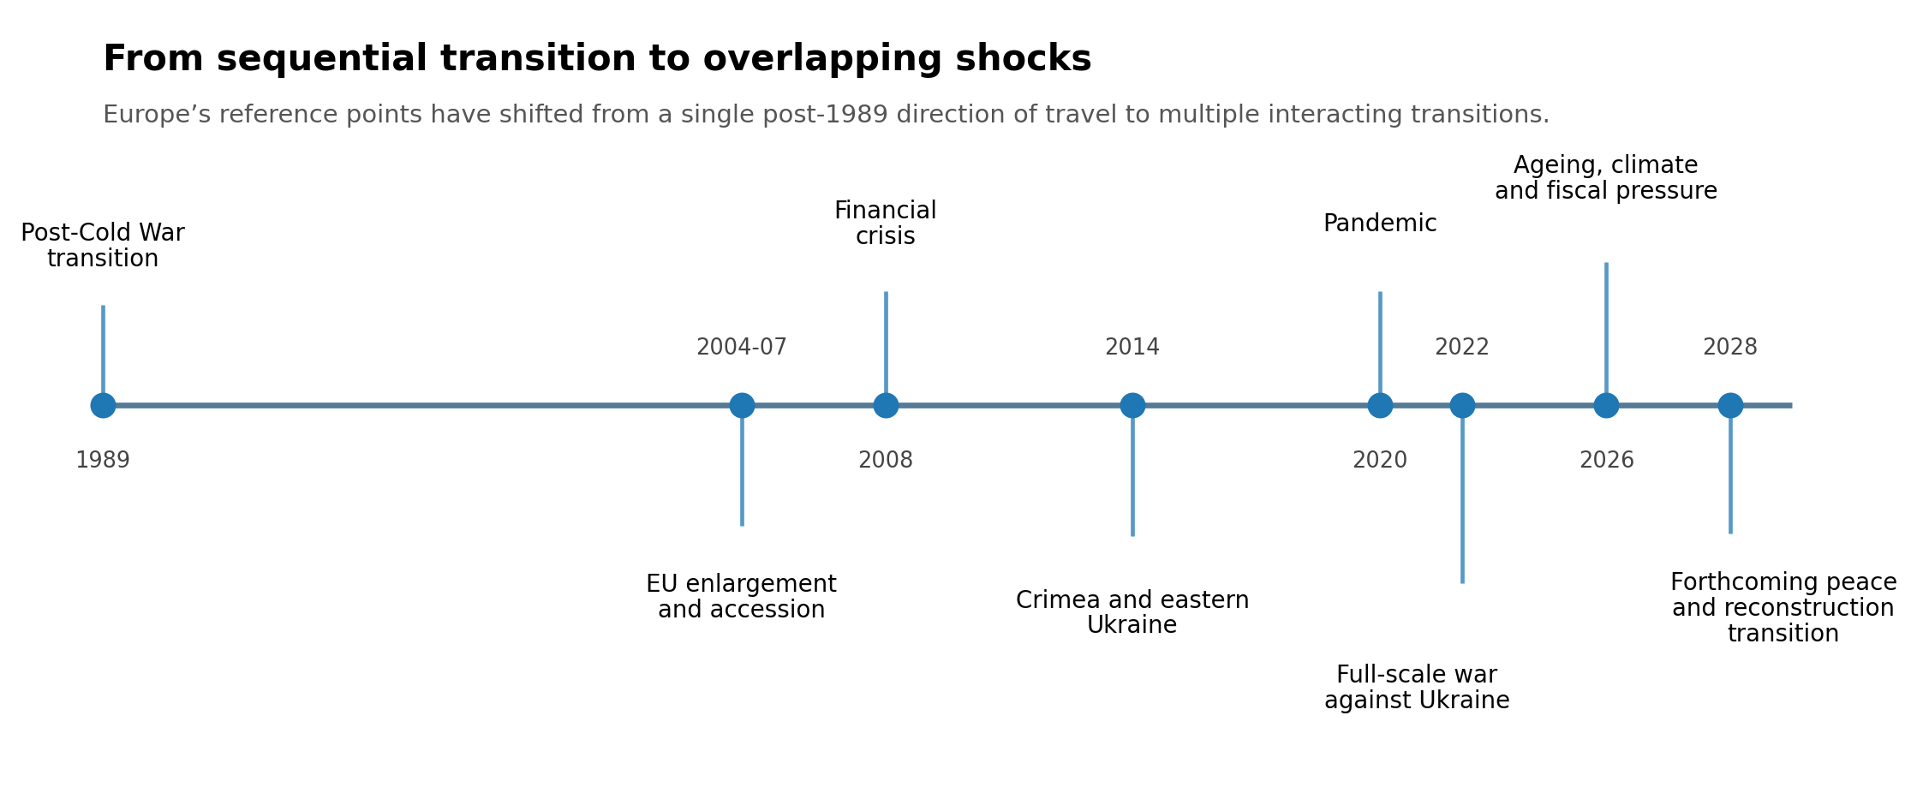
Figure 1. From sequential transition to overlapping shocks. Source: author’s interpretation, drawing on the chronology of major European transitions and shocks since 1989.

Eastern Europe as experience, not exception
Eastern Europe is often discussed as a region still catching up with the rest of Europe. There is truth in that description, but it is incomplete. The region also has experience that is increasingly relevant to Europe as a whole: experience of institutional reconstruction, migration, geopolitical pressure and rapid social change.
Countries that moved from planned to market economies learned that laws can be changed faster than habits, and institutions can be created faster than trust. They learned that reform is a political process as much as a technical one. A tax system, a competition authority, a civil service, a statistical office, a customs service or a regulatory agency cannot function well only because the legal framework exists. They require competence, resources, norms, accountability and time.
They also learned the importance of external anchors. European integration, international standards and regional cooperation helped many countries structure reform, discipline policy choices and avoid isolation. External anchors, however, cannot substitute for domestic legitimacy. Imported models fail when they are not adapted to local institutions, administrative capacity and public expectations and sometime local specificities or customs.
This is why the experience of Republic of Moldova matters. Moldova’s path has been shaped by its geography, history, size and vulnerabilities. It has had to manage economic transition, state-building, migration, energy dependence, unresolved conflict and the demands of European integration. To work in government in such a context is to understand that policy is rarely made under ideal conditions. Institutions must be strengthened while they are already under strain and reforms must be defended even when benefits are delayed. International cooperation must be translated into domestic improvements that citizens can recognize.
This is not only one country story. Across Central and Eastern Europe, many countries have lived with the feeling that history can turn quickly. Their experience should not be romanticized. Transitions produced hardship, inequalities and disappointment as well as opportunity. Yet the region’s history offers a warning against complacency and a source of practical knowledge. It shows that societies can change profoundly, but also that change without trust creates fatigue.
In the wider European debate, Eastern Europe should be seen as a region that has already confronted some of the questions now facing the continent: how to build institutions under pressure; how to maintain public support during repeated reforms; how to balance sovereignty and interdependence; how to keep a sense of direction when uncertainty is structural.

A peace transition in Ukraine
Peace in Ukraine first means an end to senseless killing, displacement, trauma and the daily destruction of homes, schools, hospitals, energy systems and livelihoods. Yet it needs to be understood also as a European political responsibility. A just and durable peace will require security guarantees and diplomatic arrangements that lie beyond the mandate of many economic institutions. Peace, once achieved, opens an enormous practical agenda. The quality of that agenda will influence whether peace becomes stable, whether citizens return, whether local economies revive, and whether reconstruction strengthens Ukraine’s democratic and European future.
The reconstruction of Ukraine will be a national transformation carried out under conditions of loss, urgency and continued risk. It will involve central government and municipalities, international financial institutions and private investors, humanitarian actors and development agencies, Ukrainian civil society and returning communities. It will require the repair of visible damage and the modernization of systems that were already under pressure before the war. Roads, railways, border crossings, electricity networks, housing, water systems and public buildings will need investment. So will institutions: procurement systems, land administration, building standards, statistical systems, environmental safeguards, local planning capacity and anti-corruption mechanisms.
The scale is already clear. The joint Rapid Damage and Needs Assessments prepared by the Government of Ukraine, the World Bank, the European Commission and the United Nations estimate recovery and reconstruction needs over a decade at several times Ukraine’s annual GDP. The exact number will continue to change as the war continues and as better information becomes available. The strategic point is that reconstruction will require coordination at a scale that cannot be improvised after peace arrives.
There is a historical resonance here for the United Nations Economic Commission for Europe (UNECE). UNECE was established in 1947 to help rebuild post-war Europe, develop economic activity and strengthen economic relations among European countries. Its early purpose was born from the recognition that reconstruction was a task that needed platforms for cooperation, standards, technical expertise and economic coordination. Nearly eight decades later, the region faces a different but related question: how can Europe organize practical cooperation for recovery in a way that strengthens peace rather than merely repairs damage?
UNECE is not a funder or a security institution. Its relevance lies in being an intergovernmental platform where countries develop and apply practical instruments across sectors that will matter deeply for Ukraine’s reconstruction: transport connectivity, trade facilitation, environmental protection, water cooperation, industrial safety, statistics, housing and urban development, sustainable energy, land administration and population policy. These are the systems through which reconstruction becomes real in people’s lives.
Transport corridors will shape Ukraine’s reintegration into regional markets and the movement of people and goods. Housing and urban planning will influence whether families can return and communities can rebuild with dignity. Environmental assessment and industrial safety will matter where infrastructure, mines, factories, water systems and ecosystems have been damaged. Energy cooperation will matter for resilience and decarbonization. Statistics will matter because reconstruction without reliable data becomes vulnerable to waste, duplication and mistrust. Trade facilitation will matter because recovery depends not only on grants and loans, but on firms, jobs and connectivity. Local governments will matter because citizens experience reconstruction in towns, cities and regions, not in abstract national aggregates.
Ukraine’s reconstruction must of course be led by Ukraine and anchored in the needs of its people. International institutions should not arrive with ready-made templates or competing visibility strategies. Their value will depend on whether they can support national priorities, reduce transaction costs, help align standards and financing, and strengthen accountability. The history of post-war reconstruction and post-socialist transition both show that external support is most effective when it combines urgency with institution-building.
A peace transition in Ukraine will therefore become one of Europe’s defining tests of permanent transition. It would test solidarity, fiscal commitment, private investment, technical coordination, institutional trust and the ability to connect reconstruction with enlargement and long-term development. It would also test whether Europe can act with the memory of its own reconstruction. ECE was created because rebuilding Europe required cooperation beyond borders and cooperation among many actors. That founding logic has not lost its relevance and it may soon need to be renewed.

The broader demographic transformation
Demography is one of the most underappreciated drivers of Europe’s future. It moves slowly enough to be ignored in daily politics, yet powerfully enough to reshape almost every area of life. Europe’s ageing is not a crisis in the narrow sense – longer lives are an extraordinary achievement of public health, education, peace and prosperity. The challenge is that many of our institutions were designed for a different age structure.
The implications reach far beyond pensions. Labour markets will have to adapt to smaller and/or older workforces. Health systems will need to manage chronic conditions and long-term care more effectively. Housing policy will need to account for accessibility, household size and loneliness. Education systems will need to support lifelong learning. Cities and rural areas will face different pressures. Migration will remain part of the demographic conversation, whether or not politics is ready to discuss it honestly.
Care is central. Too often care is treated only as a cost, a burden or a private family responsibility. Yet it is also a source of dignity, connection and solidarity. Many people care for children, parents, partners and relatives not because they are compelled by policy, but because care is part of human life. Societies cannot rely indefinitely on unpaid or under-supported care when families are smaller, women’s labour-market participation is essential, and older people live longer with complex needs. The future of care will therefore be one of the most important tests of Europe’s social model.
The intergenerational dimension is critical. Younger people are asked to finance pension and health systems, adapt to changing labour markets, pay high housing costs, support climate investment and accept delayed security in their own lives. Older people are asked to accept reforms to retirement, care and taxation after lifetimes of contribution. A politics that pits generations against each other will fail; a politics that recognizes mutual dependence has a better chance of sustaining reform.
For UNECE, this is a core area of work. The region has a long tradition of cooperation on population ageing, including through the Madrid International Plan of Action on Ageing and its regional implementation. This work is about the design of societies for longer lives: active ageing, age-friendly environments, labour-market participation, care systems, intergenerational solidarity and data that allow governments to plan responsibly.

Population aged 80+ projected to more than double by 2025

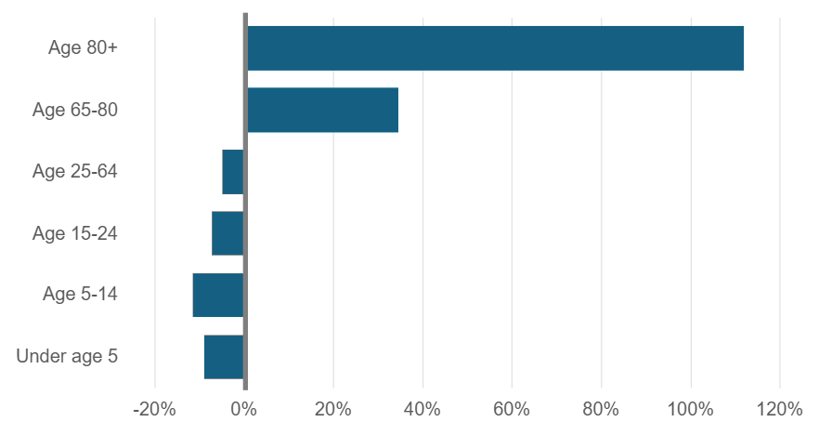

Figure 2. Demographic transition in the UNECE region – per cent change by age group, 2020-2050, UNECE

Demography also changes the meaning of productivity. In ageing societies, prosperity will increasingly depend on making better use of all available human capabilities. That includes women, older workers, persons with disabilities, migrants, young people outside employment or education, and people in regions that have been left behind. Productivity is often discussed in terms of firms and technology but it is also a question of whether societies waste human potential.

Trust as economic infrastructure
Trust is often discussed as a moral or political quality. It should also be understood as economic infrastructure. Societies with higher trust can make long-term investments, accept temporary sacrifices, comply with rules and adapt to change with lower social friction. Societies with low trust pay an invisible tax on every reform.
The UNDP Human Development Report 2023/2024 describes a world facing gridlock in collective action. Shared challenges outpace the willingness and capacity of institutions to respond. The report links insecurity, polarization and lack of trust, showing how they reinforce one another. This analysis is highly relevant to Europe. The problem is not simply that citizens disagree – democratic societies are built for disagreement. The deeper problem arises when disagreement becomes disbelief in institutions, expertise, in the good faith of others, and in the very notion that common action can produce fair results.
The politics of transition is especially vulnerable to this. When governments ask citizens to accept reform, they are making a claim about the future. They ask people to bear costs now because benefits will come later. This claim depends on credibility. If previous reforms were perceived as unfair, corrupt, poorly explained or captured by elites, the next reform begins with a deficit of trust.
This is one reason why institutional quality matters so much. Competent public administration, reliable data, transparent procurement, independent regulation and fair courts may sound less exciting than grand strategies, but they determine whether grand strategies are implemented. They also shape whether citizens believe that change is governed in the public interest.
While the OECD trust data and Eurobarometer findings are concerning, there is still considerable confidence in some institutions, and trust can be rebuilt. But the evidence suggests that governments cannot assume legitimacy. They must earn it repeatedly through performance, fairness and honesty about trade-offs. In an age of permanent transition, the ability to maintain trust may become one of the most important comparative advantages a society can possess.

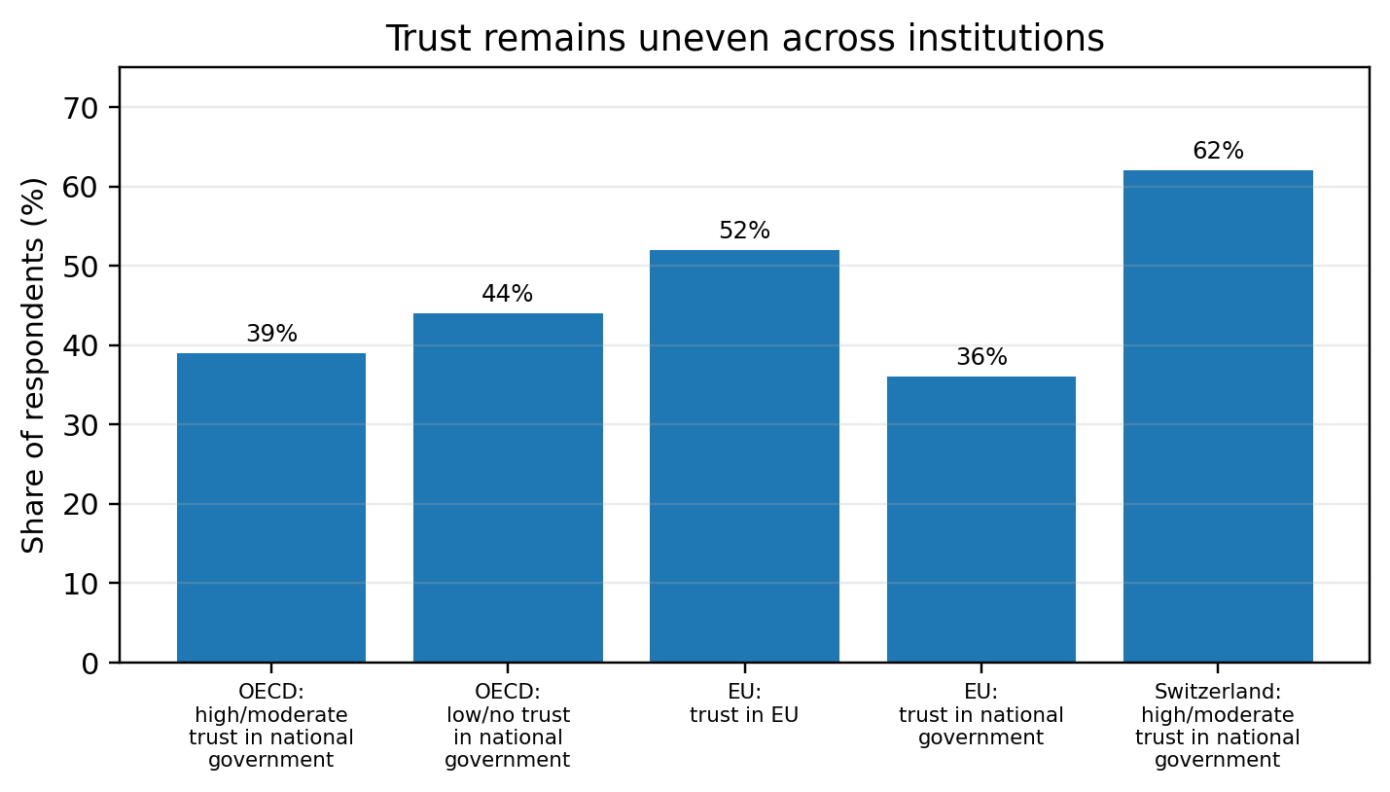
Figure 3. Trust remains uneven across institutions. Sources: OECD Government at a Glance 2025; Standard Eurobarometer 103, Spring 2025.

The quiet infrastructure of cooperation
When public debate turns to Europe’s future, attention often goes to the most visible institutions and the most dramatic questions: defence, enlargement, fiscal rules, industrial policy, migration and the future of the European Union. These questions matter. Yet much of Europe’s stability also depends on forms of cooperation that are technical, practical and often invisible.
UNECE’s mandate has evolved since its founding in 1947 within a fractured and damaged Europe. Yet its basic purpose remains highly relevant: helping countries solve practical problems together. UNECE brings together 56 member States across Europe, North America, the Caucasus, Central Asia and Western Asia. This geography matters. It creates a forum where countries that may disagree profoundly on some issues can still cooperate on practical systems that affect daily life.
UNECE’s work is broad: transport, environment, statistics, sustainable energy, trade, economic cooperation and integration, forests, housing, land management and population. These areas can sound technical. In reality, they are part of the operating system of modern societies.
This is not institutional self-description for its own sake. It is an argument about the kind of cooperation Europe needs. In a fragmented world, practical cooperation can preserve channels of trust even when political relations are strained. It can create shared habits, shared standards and shared evidence. It can reduce the cost of interdependence. It can help smaller countries access expertise and participate in rule-making and it can turn geography from vulnerability into connectivity.
The current moment gives this work renewed significance. Transport corridors matter for trade, reconstruction and security. Water cooperation matters as climate impacts intensify. Energy standards matter for decarbonization and resilience. Official statistics matter in an information environment where misinformation weakens public consent. Ageing policy matters as demographic change accelerates. Housing matters as affordability becomes a political fault line. None of these issues can be solved by declarations alone – they require patient institutional work.
One of Europe’s risks is that it undervalues the systems that function quietly until they fail. The public notices border procedures when they become slow, energy systems when they become expensive, environmental risks when disasters occur, statistics when trust collapses, and care systems when families are overwhelmed. Preventive cooperation rarely produces dramatic headlines yet it is among the most cost-effective forms of stability.

From resilience to adaptation with purpose
The language of resilience has become central to policy. Recent shocks have exposed vulnerabilities in supply chains, energy systems, health systems, public finances and security arrangements. Resilience is necessary, but the term is sometimes used too loosely. It can become a synonym for endurance, autonomy or emergency preparedness.
A more useful understanding of resilience begins with adaptation. Resilient societies are able to absorb shocks, learn from them and adjust without abandoning their core commitments. They do not confuse self-sufficiency with strength. They invest in redundancy where needed but also in cooperation. They protect vulnerable people without freezing economies in place. They maintain enough trust to make decisions before crises become unavoidable.
Permanent transition requires this kind of resilience as well as purpose. Europe now needs a clear commitment to dignity, prosperity, sustainability and peace, combined with institutions capable of adjusting policy as conditions change.
The concept of “Beyond GDP” is relevant here. Gross domestic product remains important because growth matters for jobs, revenues, investment and living standards. But aggregate growth alone cannot tell governments whether people feel secure, whether services are accessible, whether trust is improving, whether care needs are met, whether regions are converging, or whether environmental risks are being reduced. A society can grow while many citizens feel that the future is closing around them. If economic measurement misses insecurity, politics will eventually reveal it.
This does not mean replacing economics with sentiment; it means strengthening the evidence base for policy. Governments need better measures of wellbeing, inequality, resilience, sustainability, demographic change and institutional performance. They need statistics that illuminate distribution as well as averages. They need policy processes that connect long-term evidence to short-term decisions. This is another area where regional cooperation matters, because comparability and peer learning improve policy quality.
The governance of permanent transition will therefore require a different discipline and approach. Leaders must resist both fatalism and false certainty, explain trade-offs without reducing politics to management, connect reforms to a larger social purpose (including fairness), and build institutions capable of learning.

What follows for Europe
If Europe accepts that permanent transition is the condition of the age, several implications follow.
First, institutional capacity should be treated as strategic infrastructure. Public administrations, statistical systems, regulators, local governments and courts become the machinery through which societies adapt. Underinvesting in them is a form of strategic weakness.
Second, demographic adaptation must move to the centre of economic policy. Ageing, fertility, migration, care, labour-market participation and lifelong learning cannot be handled as separate social policy files. They are central to growth, fiscal sustainability and social cohesion. Europe should approach longer lives as an achievement that requires institutional redesign, not as a decline narrative.
Third, intergenerational fairness must also become a test for reform. Policies that protect current entitlements while postponing costs to younger generations will deepen political mistrust. Policies that ask older people to accept change without security or respect will also fail. The goal should be a renewed ecological social contract across generations, grounded in contribution, dignity and opportunity.
Fourth, reconstruction in Ukraine should be prepared as a European transition, not only as a future financing conference. The work must wait for the political and security conditions that make a just and durable peace possible. But the institutional architecture for reconstruction, coordination, standards and accountability should be thought through now, with Ukraine in the lead.
Fifth, practical cooperation should be protected from geopolitical fragmentation wherever possible. There will be areas where politics limits cooperation. But Europe should preserve and strengthen the technical platforms, standards and conventions that keep systems functioning.
Sixth, leaders should be honest about uncertainty. Citizens are often more capable of understanding complexity than political communication assumes. What they reject is being told that difficult reforms are painless, that all objectives can be achieved without trade-offs, or that disruption is temporary when their lived experience suggests otherwise. Honesty can be politically risky but persistent avoidance is riskier.
Seventh, Europe should draw more consciously on the experience of countries that have lived through deep transition. Central and Eastern Europe, the Caucasus and Central Asia contain many lessons about institutional change, migration, resilience, reform fatigue and the importance of external anchors. These lessons should inform Europe’s wider conversation about the future.

Conclusion: bearings without illusions
The theme of navigating a world without bearings captures a real anxiety. Many of the maps that guided Europe after 1989 no longer provide enough direction. Security assumptions have changed; demographic trends are reshaping societies; and climate risks require transformation. The pace and simultaneity of change have become politically destabilizing. The possibility of peace in Ukraine, when it comes, will add another transition of historic importance: one that will test Europe’s capacity not only to support a country under attack, but to help rebuild the conditions of long-term stability.
Europe has experience of rebuilding, adapting and cooperating, and it has the institutions, knowledge and resources that many regions would envy. It has a history of turning conflict into rules and interdependence into shared frameworks. It has societies that have already lived through profound transformation and can contribute practical wisdom to the present. It also has institutions, including UNECE, whose founding purpose was shaped by the practical requirements of reconstruction and whose contemporary work remains relevant to the systems on which recovery, resilience and cooperation depend.
Permanent transition will be demanding. It will test Europe’s social contracts, political systems and capacity for solidarity. But it can also be shaped and governed if leaders act now. The lesson of transition is that societies can change profoundly when they have direction, institutions and trust. The lesson of our present moment is that the direction will have to be renewed continuously.
Europe’s bearings will not be found in nostalgia for a more stable past. For many Europeans, that past was never stable. They will be found in the patient work of building institutions that can adapt, cooperation that can endure, and economies that give people enough security to face the future with confidence. They will also be found in how Europe prepares for the peace transition in Ukraine: with humility, coordination, institutional seriousness and the memory that reconstruction has always been one of the foundations of European cooperation. That is the work of our time.

References
Acemoglu, Daron and James A. Robinson (2012). Why Nations Fail: The Origins of Power, Prosperity, and Poverty. New York: Crown.
European Commission (2024). The 2024 Ageing Report: Economic and Budgetary Projections for the EU Member States (2022-2070). Institutional Paper 279. Luxembourg: Publications Office of the European Union.
Eurobarometer (2025). Standard Eurobarometer 103: Public opinion in the European Union, Spring 2025.
Eurostat (2026). Population structure and ageing; Population projections in the EU. Statistics Explained. Data extracted February 2026.
Fukuyama, Francis (1992). The End of History and the Last Man. New York: Free Press.
Government of Ukraine, World Bank Group, European Commission and United Nations (2026). Ukraine Fifth Rapid Damage and Needs Assessment (RDNA5): February 2022 - December 2025. Washington, DC: World Bank.
Krastev, Ivan and Stephen Holmes (2019). The Light That Failed: A Reckoning. London: Allen Lane.
OECD (2025). Government at a Glance 2025. Paris: OECD Publishing. https://doi.org/10.1787/0efd0bcd-en.
UNDP (2024). Human Development Report 2023/2024: Breaking the Gridlock - Reimagining Cooperation in a Polarized World. New York: United Nations Development Programme.
UNECE (2026). History of UNECE; areas of work and 2030 Agenda implementation materials.
World Bank (2026). Europe and Central Asia Economic Update, April 2026. Washington, DC: World Bank.

